Activity Instructions

Analyze the data presented in the graph and table below. Then write a summary addressing the following:
1. The histogram below shows the total estimated new breast cancer cases diagnosed in 2003.
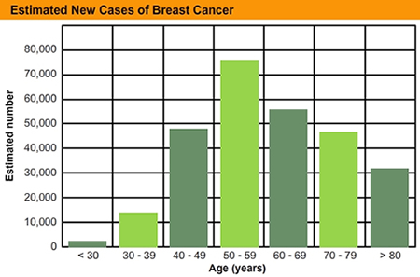
© 2011 FLVS
2. The results in this table below are from a 2007 study investigating BRCA mutations in women diagnosed with breast cancer. All of the women in the study had a family history of breast cancer.
BRCA Mutations in Women Diagnosed with Breast Cancer
 | BRCA1 mutation | BRCA2 mutation | No BRCA mutation | Total
Number of patients | 89 | 35 | 318 | 442
Average age at diagnosis | 43.9 | 46.2 | 50.4
Preventive mastectomy* | 6 | 3 | 14 | 23
Preventive oophorectomy* | 38 | 7 | 22 | 67
Number of deaths | 16 | 1 | 21 | 38
Percent died | 18 | 2.8 | 6.9 | 8.6
*A mastectomy is the surgical removal of one or both breasts, either partially or fully. An oophorectomy is the surgical removal of an ovary or ovaries.
Things to address in your summary essay:
- Describe how mutations lead to genetic variations.
- Which appears to be more dangerous: the BRC1 or BRC2 mutation?
- Analyze a woman’s risk of dying of cancer if she carries a mutated BRC1 gene.
- How do heredity and inheritance relate to the data presented in these charts?
- What data would you need to see in order to draw conclusions about the effectiveness of preventive surgeries?
- What does the age at diagnosis tell you about the mutation?
- Explain how breast-cancer genes are still present in the population, despite cancer-related surgeries and deaths.

