01.04 How Theme Develops Assignment

Complete this assessment and submit it in the Assessment Area for 01.04.
Instructions: Read the story below, taking special note of the literary elements of setting, protagonist, conflict, climax, and resolution.
The Nest
by Violet Sorzano
Randall squinted up through the trees, trying to gauge the time, but gave up quickly. He should have paid attention when his father taught the family to read the position of the sun. He should have paid attention, too, before sneaking off this morning on his first solo hike, forgetting the whistle his mother stressed he always bring.
He pictured his parents now at their camp beneath the tree with the eagle’s nest, wondering where he was. Randall was wondering the same thing. Lost and out of food, he feared he had but a few hours before darkness closed in, trapping him in the bitter cold with the creatures of the night.
He closed his eyes to fight back tears, when he heard it in the distance. Water! His father’s words came flowing into his mind; one tip he actually remembered. “If you’re ever lost, find a river and follow it.”
In a flash, he was on his feet, scaling fallen trees, tearing through brush, frantically following the sound. The sky grew darker, but the noise grew louder, and Randall, tired and scared, forged ahead until he found it. He reached the river bank and was mulling his next move when a sudden splash caught his eye.
A majestic eagle rose from the water, soaring skyward with a freshly caught fish in its talons. Could it be the same eagle nested above his camp? It glided triumphantly into a high nest a short distance away, eager to greet its family. Randall smiled, equally triumphant, eager to do the same as he followed the eagle’s flight.
In the distance, he saw his mother, his whistle clutched in her hand.
Part 1: Under the graphic organizer, type a description of each literary element from the story “The Nest.”
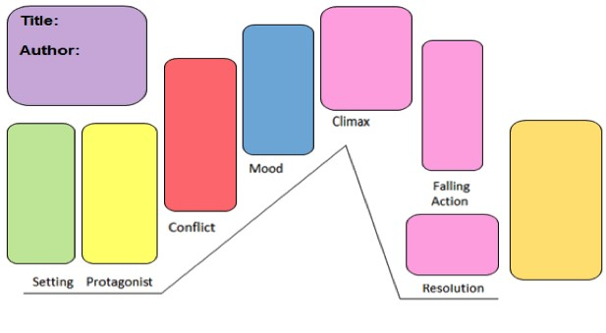
Listen to your elders.
The eagle led him to its nest and he finds home.
He follows an eagle
He runs to find a river
Scared
Randall gets lost in the forest
Randall
The Forest
Violet Sorzano
The Nest
Setting: Forest
Protagonist: Randall
Conflict: He’s Lost
Mood: Scared
Climax: He finds a river and sees and eagle
Falling Action: He follows the eagle to its nest
Resolution: He finds his home by following the eagle
Theme: Listen to your elders.
Part 2: Using the information in your graphic organizer, write a paragraph in the space below explaining how theme develops in the story "The Nest."
In the story “The Nest” by Violet Sorzano the theme is “listen to your elders”. I know this is the theme because in the story Randall takes a hike in the forest by himself, he then gets lost in the forest. He wishes he had listened to his father or taken the whistle his mother told him to take everywhere, he knew his parent didn’t know where he was. The antagonist in this story is himself because he did not listen, the conflict is he got lost because he didn’t listen, and the falling action is because he had listened to one thing his father said. “When your lost find a river and follow it,” so Randall found a river and found an eagle he followed the eagle to its nest. The resolution is that when he followed the eagle to its nest, he found his home and wasn’t lost anymore. In the story Randall was scared because it was almost dark and he was lost. This how I know the theme of the story.
- Write a topic sentence that mentions the theme, title, and author.
- Then follow your graphic organizer and write your ideas about how protagonist, antagonist, conflict, falling action and resolution, mood, and setting develop in the story. C. Be sure to include the theme of the story.
D. End with a sentence that restates your idea about the theme.
Here is an example using the Shanice and Clara story:
"One Goal" by Davis Grandy has a theme of "Teamwork is more important than individual success." The theme develops in the story as the protagonist, Shanice, faces off against the antagonist, Clara. It is a character vs. character conflict as they battle each other for the final spot on the soccer team. The school setting provides Clara with many chances to taunt Shanice, and as the mood of the story turns anxious for the reader, Shanice stays focused on preparing for the tryout. In the climax, Shanice has a chance to kick a goal and make the team, but she passes to Clara and lets her score instead. In the falling action, the coach rewards Shanice’s sense of teamwork by putting her on the team, and Clara gets in trouble for her bad behavior. In the resolution, they decide to be friends again. The author develops the theme perfectly by blending the literary devices to create a story where the protagonist learns an important lesson.
The paragraph above clearly expresses the development of the story's theme.

PRINT SAVE

