Curated Practice Problem Set

Unit 1 Lesson 4 Cumulative Practice Problems
- This diagram is a straightedge and compass construction. $A$ is the center of one circle, and $B$ is the center of the other. Explain how we know triangle $ABC$ is equilateral. The triangles have the same distance. It has internal angles, and they are 60 degrees.
- 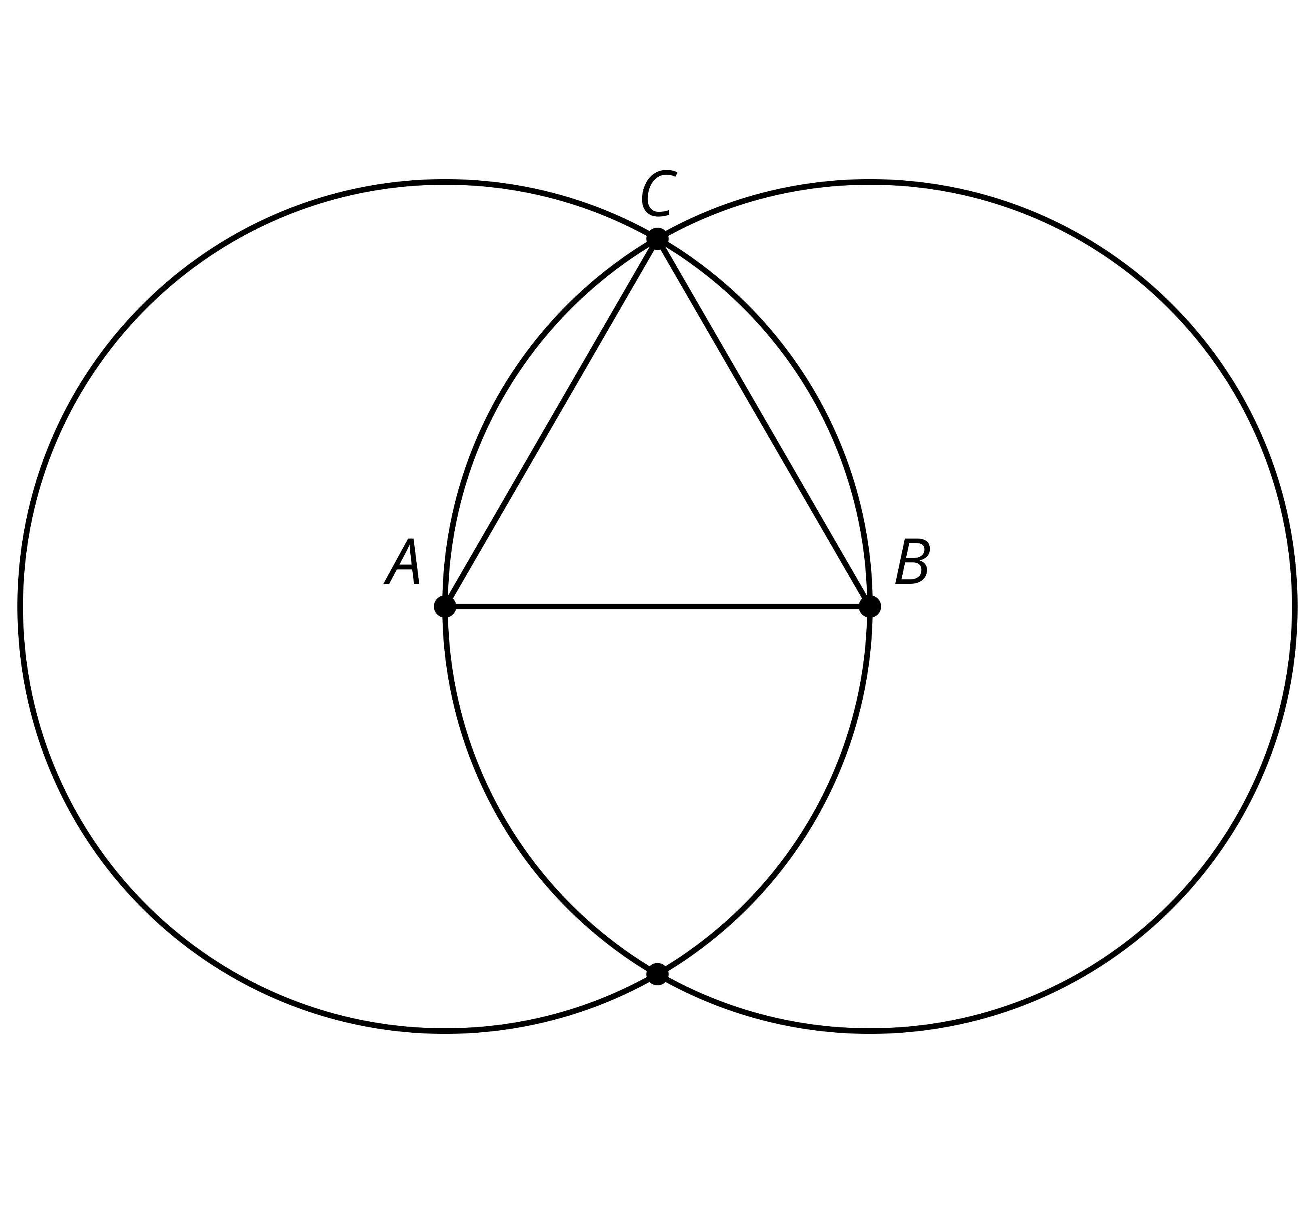
- $A$, $B$, and $C$ are the centers of the 3 circles. How many equilateral triangles are there in this diagram? There are 1 equilateral triangle.
- 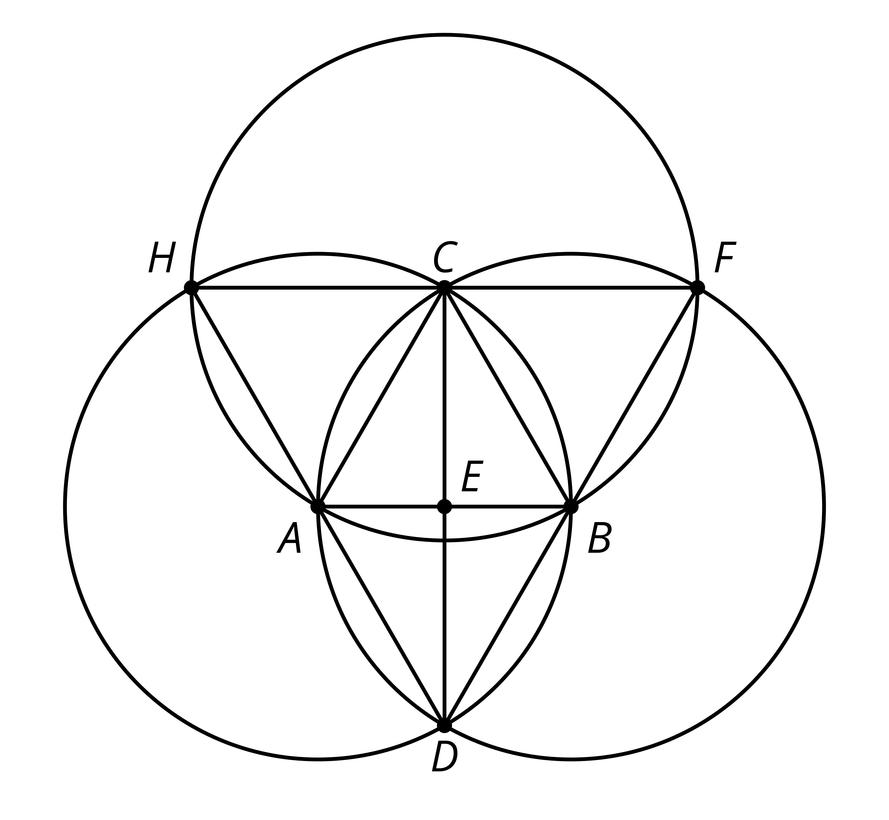
- This diagram is a straightedge and compass construction. $A$ is the center of one circle, and $B$ is the center of the other. Select all the true statements. 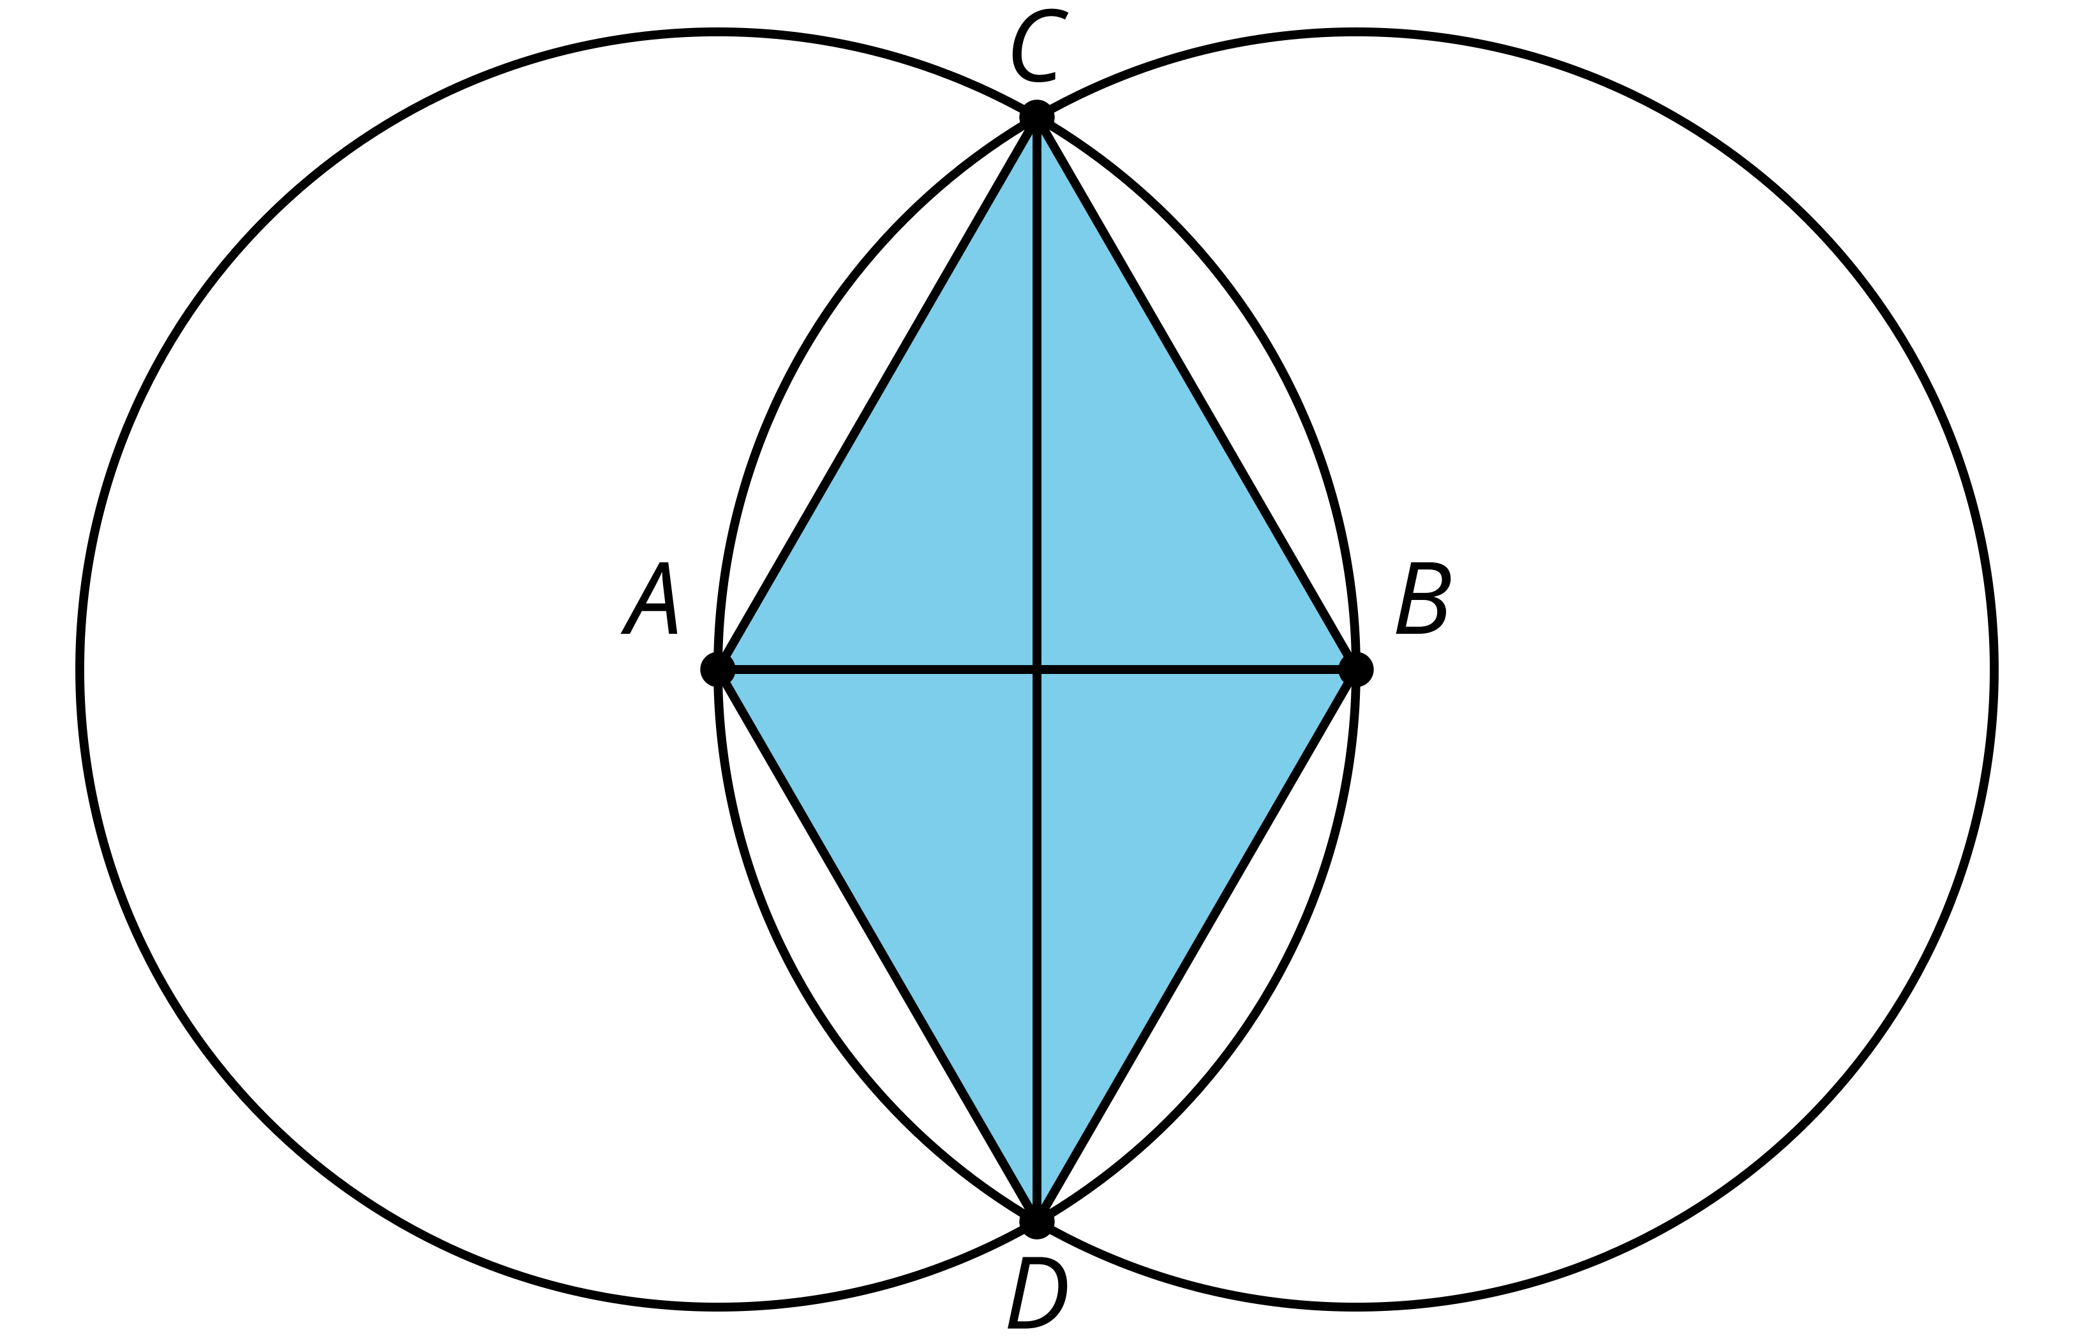
  - $AC=BC$ correct
  - $AC=BD$ correct
  - $CD=AB$ incorrect
  - $ABCD$ is a square. correct
  - $ABD$ is an equilateral triangle. incorrect
  - $CD=AB+AB$correct
- Line segment $CD$ is the perpendicular bisector of line segment $AB$. Is line segment $AB$ the perpendicular bisector of line segment $CD$? yes
- 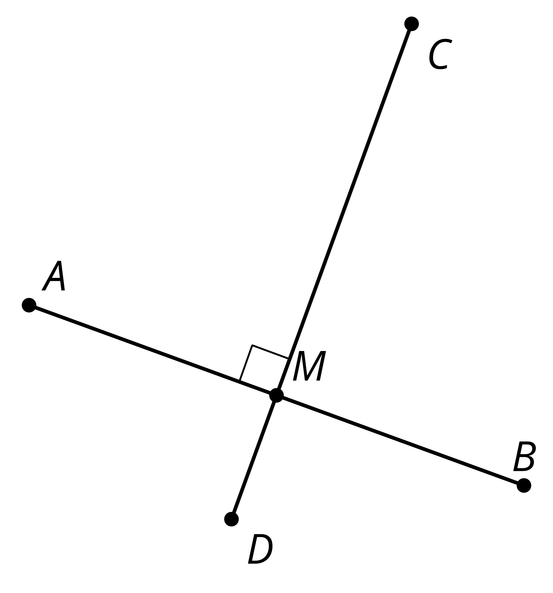
- (From Unit 1, Lesson 3.)
- Here are 2 points in the plane.
- 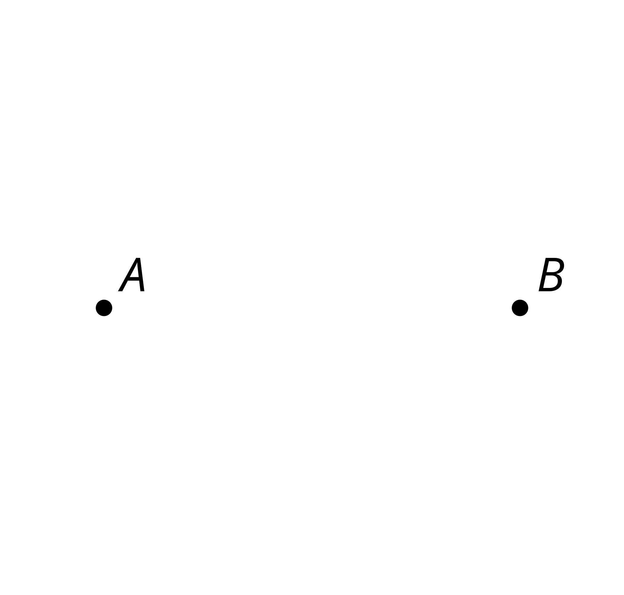
  - Using only a straightedge, can you find points in the plane that are the same distance from points $A$ and $B$? Explain your reasoning.
  - Using only a compass, can you find points in the plane that are the same distance from points $A$ and $B$? Explain your reasoning.
- (From Unit 1, Lesson 3.)
- In this diagram, line segment $CD$ is the perpendicular bisector of line segment $AB$. Assume the conjecture that the set of points equidistant from $A$ and $B$ is the perpendicular bisector of $AB$ is true. Select all statements that must be true.

- $AB⊥CD$
- 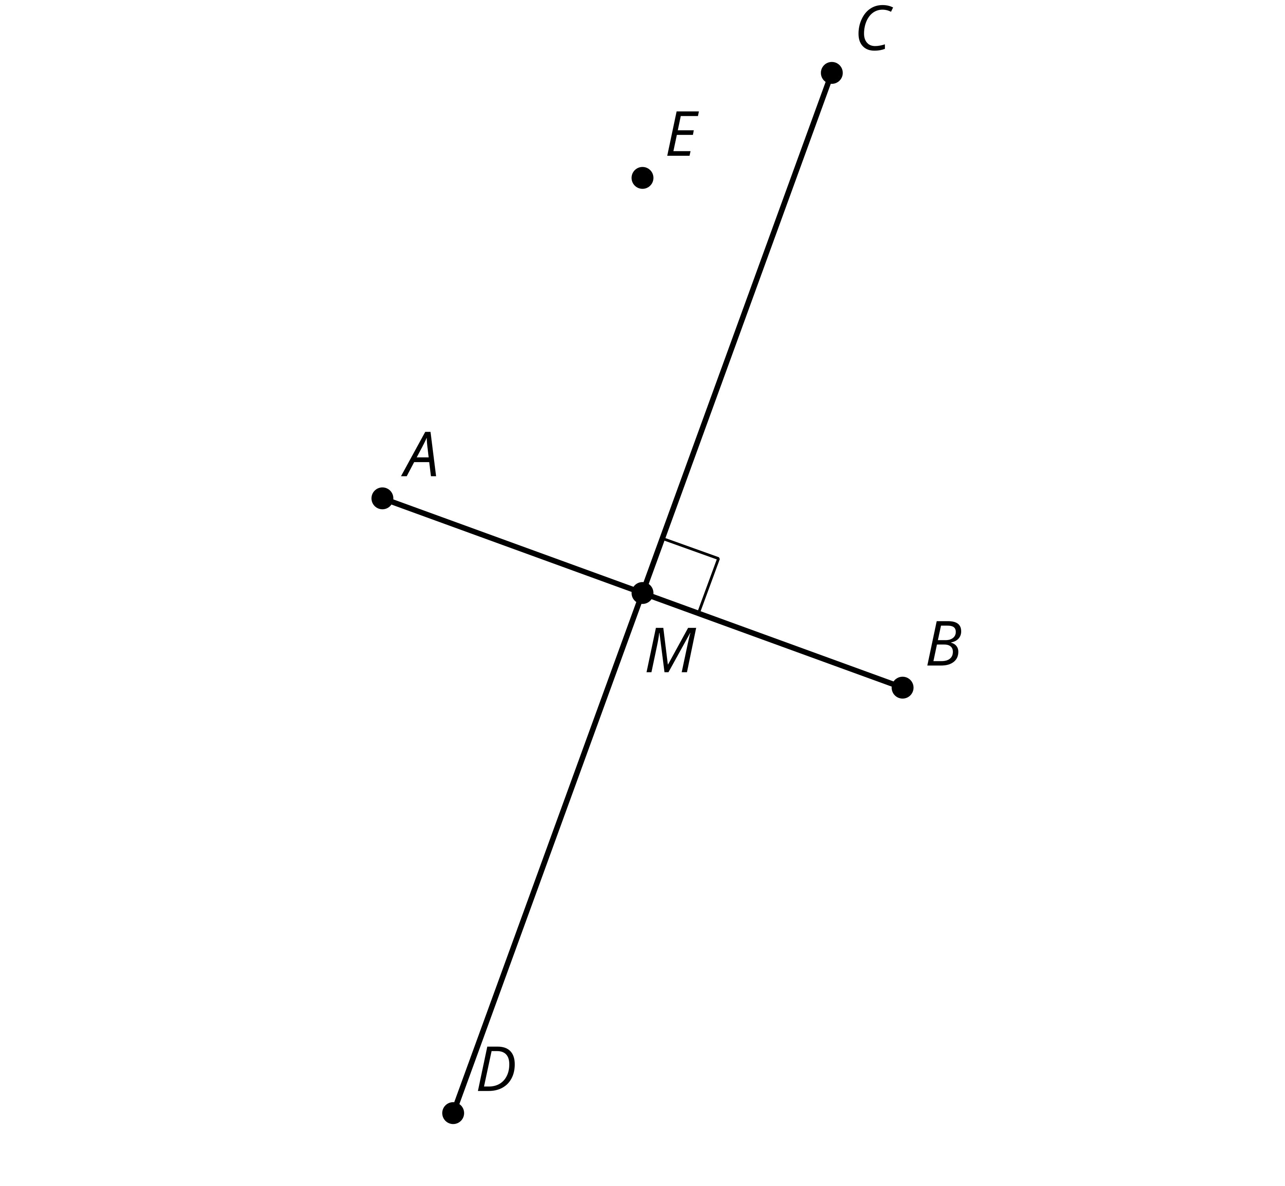
  - $AM=BM$
  - $CM=DM$
  - $EA=EM$
  - $EA<EB$
  - $AM<AB$
  - $AM>BM$
- (From Unit 1, Lesson 3.)
- The diagram was constructed with straightedge and compass tools. Name all segments that have the same length as segment $AC$.
- 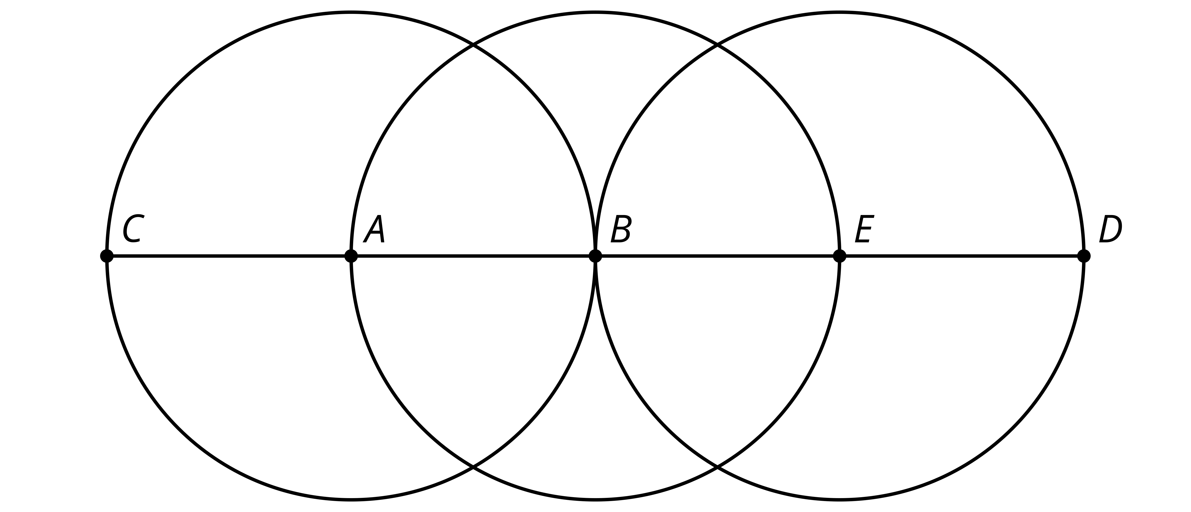
- (From Unit 1, Lesson 1.)
- Starting with 2 marked points, $A$ and $B$, precisely describe the straightedge and compass moves required to construct the quadrilateral $ACBD$ in this diagram.
- 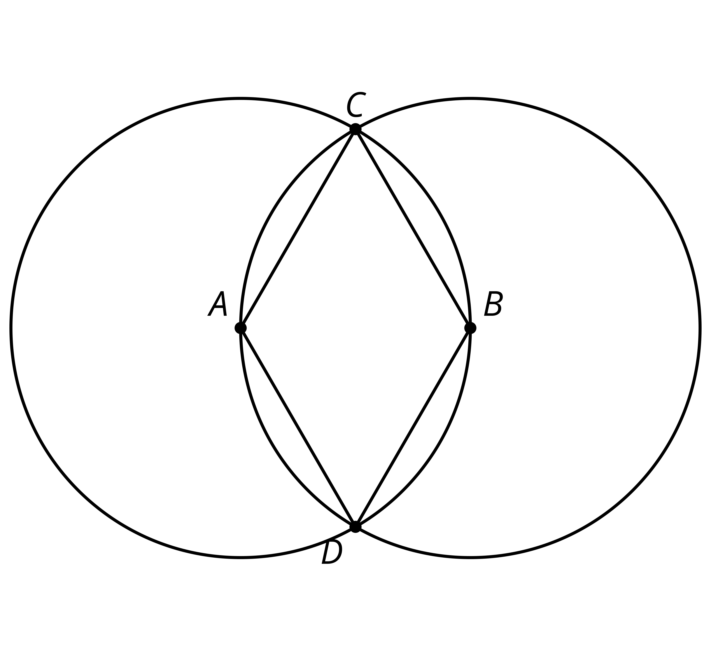
- (From Unit 1, Lesson 2.)
- In the construction, $A$ is the center of one circle and $B$ is the center of the other. Which segment has the same length as $AB$?
- 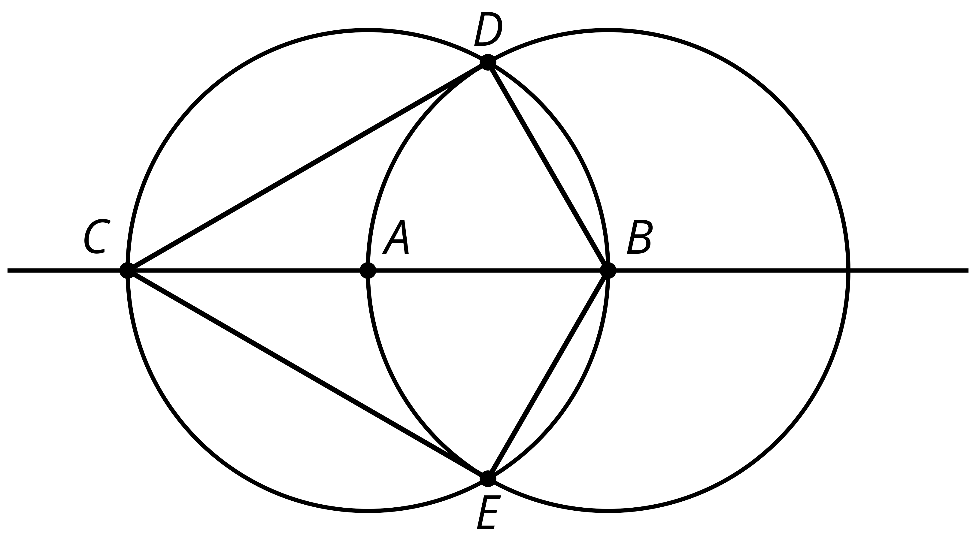
  - $CB$
  - $CD$
  - $CE$
  - $CA$
- (From Unit 1, Lesson 2.)
© CC BY 2019 by Illustrative Mathematics

