Angle Leader_____________________________ Date ________________ Per. ___

7th Grade, IU 5, Formative Assessment #3

- Angle RST is a right angle. What is the measure of angle UST?

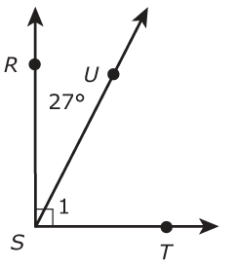

- 27°
- 36°
- 63°
- 81°

- In the diagram, line GH is perpendicular to line IJ.

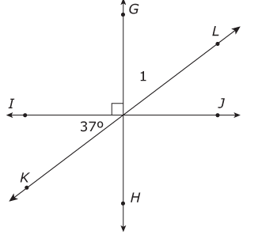
What is the measure of angle 1?

- 37°
- 53°
- 63°
- 74°

- What is the measure of angle PQS in the figure below?
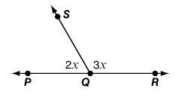
- 36°
- 60°
- 72°
- 108°

- A student uses this figure to find the measure of angle S.
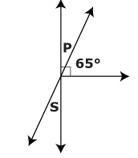

The student first finds the measure of angle P. Why does finding the measure of
angle P help the student find the measure of angle S?

- Angle P and Angle S are adjacent angles and they add up to 90°.
- Angle P and Angle S are vertical angles and they add up to 90°.
- Angle P and Angle S are adjacent angles and they are equal.
- Angle P and Angle S are vertical angles and they are equal.

