Angle Leader_____________________________ Date ________________ Per. ___

3.) What is the measure of angle PQS in the figure below?
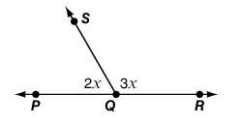
- 36°
- 60°
- 72°
- 108°

4.) A student uses this figure to find the measure of angle S.
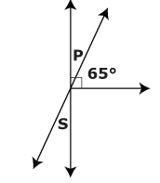

The student first finds the measure of angle P. Why does finding the measure of
angle P help the student find the measure of angle S?

- Angle P and Angle S are adjacent angles and they add up to 90°.
- Angle P and Angle S are vertical angles and they add up to 90°.
- Angle P and Angle S are adjacent angles and they are equal.
- Angle P and Angle S are vertical angles and they are equal.

