Felix drew two box-and-whisker plots to compare the same sets of data:
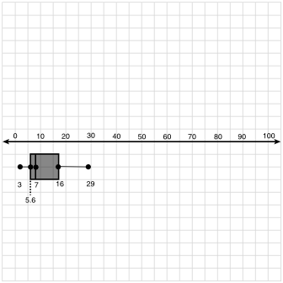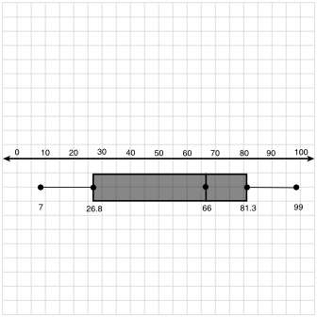
In the form of a paragraph, use complete sentences to describe some of the differences in the prices of the two sets of books. Refer to the box and whisker plots to justify your answer.

