Question 1(Multiple Choice Worth 3 points)
The image below illustrates a right protected in the Bill of Rights.
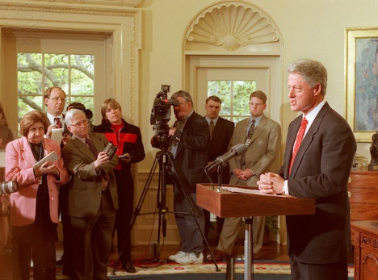
What right protected by the Bill of Rights does this image illustrate?
Voting rights Property rights Freedom of religious expression Freedom of the press

Question 2(Multiple Choice Worth 3 points)
The image below illustrates a right protected by the U.S. Constitution.
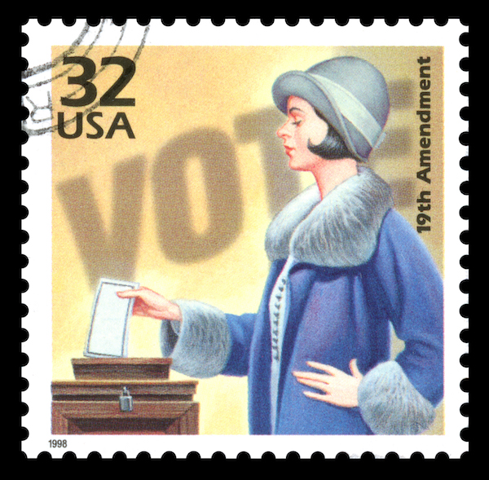
What right protected by the U.S. Constitution does this image illustrate?
Free speech Property rights Free press Suffrage

Question 3(Multiple Choice Worth 3 points)
The statement below was made to an interviewer in Atlanta, Georgia in the 1930s.
Do you know I've never voted in my life, never been able to exercise my right as a citizen because of the poll tax?
How is this concern addressed in the U.S. Constitution?
By making all taxes unconstitutional By making barriers to voting unconstitutional By limiting voting rights for some Americans By giving noncitizens the right to vote

Question 4(Multiple Choice Worth 3 points)
The table below lists protected constitutional rights and how they may be limited.
Protected Rights | Limitations
Freedom of speech | ?
Unwarranted search and seizure | Crime suspects may be searched
Which phrase completes the table?
Threats to public safety Eminent domain Jury trial Background checks

Question 5(Multiple Choice Worth 3 points)
The table below lists protected constitutional rights and how they may be limited.
Protected Rights | Limitations
Public trial | ?
Unwarranted search and seizure | Crime suspects may be searched
Which phrase completes the table?
Poll taxes Safety of the accused Eminent domain Background checks

Question 6(Multiple Choice Worth 3 points)
The table below lists protected constitutional rights and how they may be limited.
Protected Rights | Limitations
Right to bear arms | ?
Unwarranted search and seizure | Crime suspects may be searched
Which phrase completes the table?
Poll taxes Eminent domain Jury trial Background checks

Question 7(Multiple Choice Worth 3 points)
Which of the following is an individual right protected by the Bill of Rights?
Jury trial Eminent domain Voting Independent judiciary

Question 8(Multiple Choice Worth 3 points)
Why was the Bill of Rights added to the U.S. Constitution?
To declare independence from Britain To create the three branches of government To safeguard Americans' rights To enforce important laws

Question 9(Multiple Choice Worth 3 points)
The passage below about debate is from a 1964 Supreme Court ruling.
Debate on public issues should be uninhibited, robust, and wide-open and it may well include unpleasantly sharp attacks on government and public officials.
How does the U.S. Constitution protect this right?
The U.S. Constitution protects the executive branch from public criticism. The U.S. Constitution protects the judicial branch from public criticism. The U.S. Constitution provides unlimited protection of individual rights. The U.S. Constitution protects the rights of people and the press to speak out.

Question 10(Multiple Choice Worth 3 points)
The passage below about government is from the Federalist No. 47.
The accumulation of all powers, legislative, executive, and judiciary, in the same hands… may justly be called the very definition of tyranny.
How is the author's view from this passage reflected in the U.S. Constitution?
The U.S. Constitution gives unlimited power to the judiciary. The U.S. Constitution creates an independent judiciary. The U.S. Constitution requires the executive branch to approve decisions of the judicial branch. The U.S. Constitution requires the legislative branch to approve

