2.09 Reliable Websites Worksheet

Part 1: Compare the Websites
You are conducting research for a project about elephant sanctuaries. Compare the two websites using the 5 W’s criteria for reliability and validity. For each website, complete the 5 W’s Checklist.

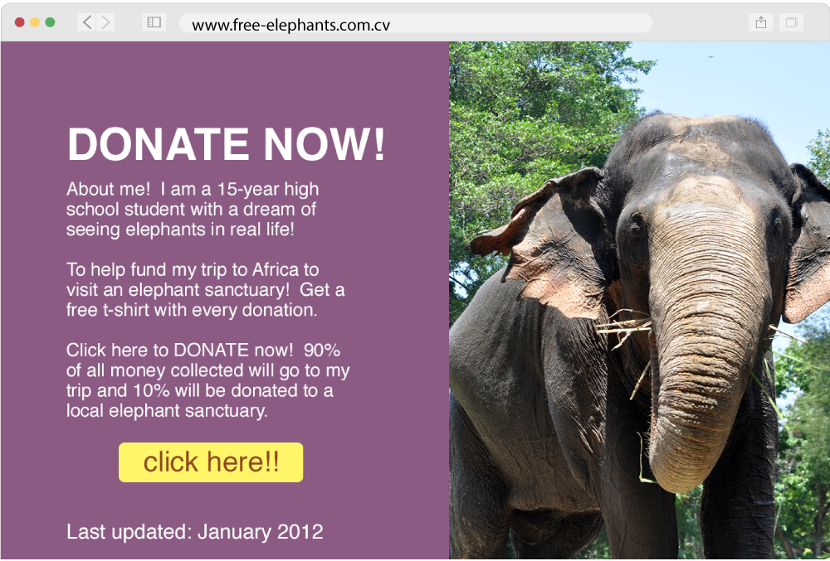
Website #1
- WHO created the website? A 15-year-old high school student

- WHAT information is on the website? 90% of all money collected will go to his trip and 10% will be donated to a local elephant sanctuary.

- WHEN was the information last updated? January 2012

- WHERE did you find it? (hint: what does the website URL tell you?) on

- WHY was the website created? To help a kid reach his dream!

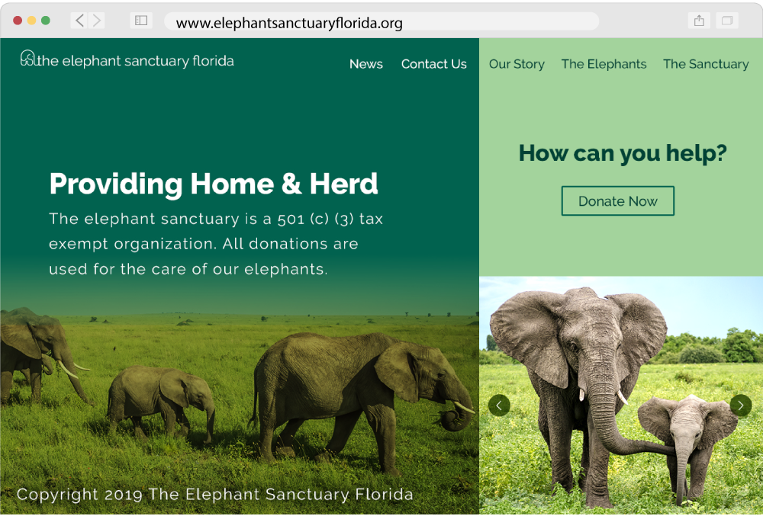
Website #2
- WHO created the website?

- WHAT information is on the website?

- WHEN was the information last updated?

- WHERE did you find it? (hint: what does the website URL tell you?)

- WHY was the website created?

Part 2: Reflect
After reviewing the websites and completing the 5 W’s Checklists, answer the following questions using complete sentences. Each answer should contain 3–5 sentences.
- Which website would you use for your research on elephant sanctuaries?

- If you were creating your own website, what would you include to make sure your website was reliable and valid?

Part 3: Save Your Work
Don’t forget to save this worksheet. You will submit it for your assessment.

