 | 6.5.4 Journal: Point on a Circle |  | Journal
 | Mathematics II Sem 2 | Name:
 | Mathematics II Sem 2 | Date:
Scenario: Pony Ride
Instructions:
- View the video found on page 1 of this journal activity.
- Using the information provided in the video, answer the questions below.
- Show your work for all calculations

The Students’ Conjectures: The students are running a pony ride business. They are trying to decide where to stake the pony so that the pony can't reach the fence or trample a rose bush. The rose bush is located 16 feet over and 18 feet up from the bottom left corner. That can be represented by (16, 18). David is putting the pony on a 10-foot rope.
1. Complete the table below to summarize what you know about each student’s conjecture: (2 points, 1 point for each row of the chart)

Classmate | Conjecture
David | David wants to put the rope 10 feet up and 10 feet over to protect the rose bush.
Joy | Joy thinks he should put the rope 8 feet over and 8 feet up to protect the rose bush.

Analyze the Conjecture:
2. What are the arguments against each student's plan? (1 point)
The arguments against each student's plans are that they both disagree on the amount of feet to put the rope up and over. Joy says 10 ft up and over and David says 8ft up and over.

Analyze the Data: Suppose that this grid represents the customer’s yard. The bottom left corner is the origin point, (0, 0), and the x- and y- axes represent the two fences. The rose bush is at point (16, 18).
Use this graph for questions 3 through 13.
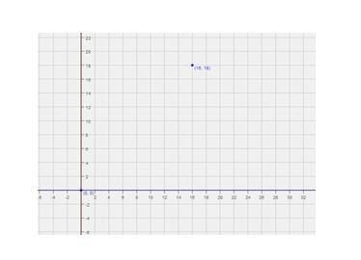
David's Plan:
3. What are the coordinates of the point where David wants to put the stake? Draw this point on the graph. (1 point)
(10,10)

4. If they stake the pony where David wants, what is the equation of the circle that represents the pony’s path? (2 points)
a) What will be the radius of the pony’s path? (1 point)

b) Remember that the equation of a circle whose center is not at the origin is 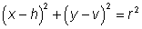where (h, v) is the center of the circle. Use this to help you write the equation. (1 point)

5. Sketch the circle represented by this equation onto the graph. (1 point)

6. To check whether the rose bush lies on the circle, see if its coordinates make the equation for the circle true. Show your work.(2 points)

Joy's Plan
7. What are the coordinates of the point where Joy wants to put the stake? Draw this point on your graph. (1 point)

8. If they stake the pony where Joy wants, what is the equation of the circle that represents the pony’s path? (2 points)

9. Sketch the circle represented by this equation on the graph. (1 point)

10. To check whether the rose bush lies on the circle, see if its coordinates make the equation for the circle true. Show your work. (2 points)

11. If the pony is staked at the point (8,8), is the pony able to move about freely without running into the fence? Explain your answer using the location of the stake and the length of the rope to support your reasoning. (1 point)

Making a Decision

12. Who was correct? Is either point (10, 10) or (8, 8) a good place to stake the pony? (1 point)

13. Consider the circle with equation (x – 12)² + (y – 12)² = 100.

a) What is the center of this circle? (1 point)

b) Would this circle work for the pony's path? Why or why not? Explain your answer by using the equation, the location of the stake, and the length of the rope to support your reasoning. (2 points)

Copyright © 2018 Apex Learning Inc. Use of this material is subject to Apex Learning's Terms of Use. Any unauthorized copying, reuse, or redistribution is prohibited. Apex Learning ® and the Apex Learning Logo are registered trademarks of Apex Learning Inc.
6.5.4 Journal: Point on a Circle

