Select the graph that would represent the best presentation of the solution set.
\absP>3
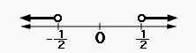
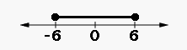
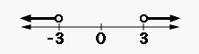
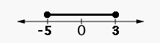
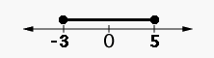
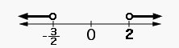
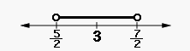

Select the graph that would represent the best presentation of the solution set.
\absx<5
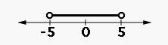
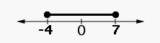
Select the graph that would represent the best presentation of the solution set.
\absx>12
