Assignment: 4.16 TGA- Write a Short Story 50 points

Overview:
For this assignment, you will write a short story of your own–a short one, about 500-1000 words long. However, even though your short story won't be very long, it will contain lots of the same elements as a much longer novel.

Your short story must include*:
- An exposition, rising action, complicating incident, climax, and resolution
- A setting, plot, and theme
- Sensory details and rich description to capture the reader’s attention and develop a mood
- A narrator with a consistent point of view
- Dialogue to move the plot and show the characters’ ideas and feelings
- Consistent verb tense
- Appropriately selected and implemented active and/or passive voice
- Correct capitalization, punctuation, and spelling.

*Please review the sample short story at the end of this document for clear directions on how to incorporate all of these requirements into your short story.

How To Use This Guide:
- Each step will walk you through the process of PLANNING your short story–be sure to read through all pages of the document and complete ALL the steps
- There are places to make notes that will help you ORGANIZE your ideas
- You will need to WRITE the actual short story in a SEPARATE DOCUMENT to be submitted in the classroom.
- You will submit your short story in Lesson 4.16 of the OMHS

Step 1- Choose your Character, Setting, and Problem

Before you get started writing, you should have some basic idea about:
- who your characters will be
- Where and when the story takes place
- what problem arises to create the conflict in the story

The sky's the limit! In case you are having trouble getting started, you can choose one item from each column to help your ideas start flowing:

Main Character | Setting | Main Problem/Conflict
A kind 2 headed monster | At a school dance | Was chased by a tornado
A grumpy bear | At the mall | Lost their memory
A feisty princess | In a hot desert | Got separated from their friend
A shy teenager | In a dark forest | Got lost in space
A lonely alien | In Walmart | Ate a poisoned berry
A sarcastic cat | In an ambulance | Locked in the bathroom
An anxious superhero | In the basement | Ran out of gas

Add some notes about YOUR story ideas here:
Main Character | Setting | Main Problem/Conflict

Step 2- Deciding Your Plot

Now that you have decided your characters, setting, and problem/conflict, it’s time to plot your story! Your story should include:
- a clear beginning
  - EXPOSITION noting the characters and setting
- rising action
  - a COMPLICATING INCIDENT or problem that drives the action of the story
- a climax
  - this is the HEIGHT of tension and excitement–the point of no return
- Falling action that leads to a resolution
  - the story should gradually come to a close, not an abrupt “The End”
  - a sense of closure

To help you along, consider the questions on the story plot chart:
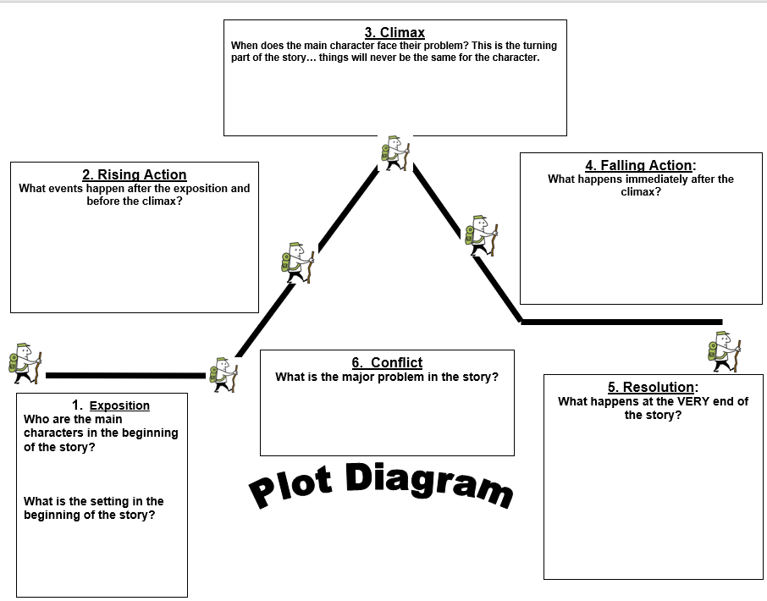

Write a brief paragraph that summarizes the beginning, middle, and end of your story

Step 3– Deciding Your Point of View
Will your story be written in:
- First person point of view [main character is telling the story using “I,” “we,” “me”
- Second person point of view [addressing the audience directly]
- third person point of view [imagine an outsider is telling the story, using pronouns such as he, she, they, them, their, etc.]
Will you write your story in FIRST, SECOND, or THIRD person point of view?

Step 4: Deciding Your Verb Tense
How will you tell your story? Will you tell it in present tense, as though the story is happening live in the moment, or will you tell your story in past tense, as though it has already happened? However you choose to tell it, you must make sure your verbs are consistent throughout.
For example, if you are writing in present tense, you would write “Johnny says.”
If you are writing in past tense, you would write, “Johnny said.”
All of your verbs must follow suit!
Will you write your story in PAST TENSE or in PRESENT TENSE?

Step 5- Deciding Your Theme
What is the moral of your story? What do you want the overall lesson to be when your reader finishes your story? It should be developed through things the characters say, do, and interact with their settings and the conflict. By the resolution of your story, your theme should be apparent.
Example:
- In the story of Beauty and the Beast, you see characters who don’t “fit in” for various reasons: a beast who is feared and made an outcast because of his appearance; a young woman who is different because of her interests and her eccentric father. The events of the story encourage the audience to value INWARD characteristics like love and kindness overall. This is the theme.
What will be one THEME in your short story?

Step 6- Begin to Write!
Now, open a separate document and bring your ideas to life. Start at the beginning!
- Be sure to introduce the story, so that the reader knows where and when the story is taking place.
- The conflict or problem should arise within the first or second paragraph.
- Your characters should talk to each other! Dialogue is a requirement for this assignment.
- If you only have one character, they should talk to themselves.
- Your characters tell the story as much as you do. Have them explain what’s happening to provide background information and what is happening in the story.
- Follow your story plot chart.
- The first step is simply to write! Don’t be nervous, don’t over analyze. You will go back and edit your writing for your next step.
Pro-Tip: Wait 24 hours before editing your story. Let it “marinate”. When approaching your work with fresh eyes, you may catch grammatical errors you missed the first time.
Step 7- Check Your Work!
Before submitting, check that your short story meets ALL of the following criteria:
- 500-1000 Words *You can quickly see how many words are in your assignment using this website: https://wordcount.com/ *
- An exposition, rising action, complicating incident, climax, and resolution
- A setting, plot, and theme
- Sensory details and rich description to capture the reader’s attention and develop a mood
- A narrator with a consistent point of view
- Dialogue to move the plot and show the characters’ ideas and feelings
- Consistent verb tense [must stay in PAST or PRESENT tense throughout]
- Appropriately selected and implemented active and/or passive voice
- Correct capitalization, punctuation, and spelling.

And remember– edit, edit, edit! It is okay for you to use improper grammar in your dialogue, but not in other places throughout your story. Do not submit one giant block of text. Indent new lines and separate your dialogue with quotation marks.

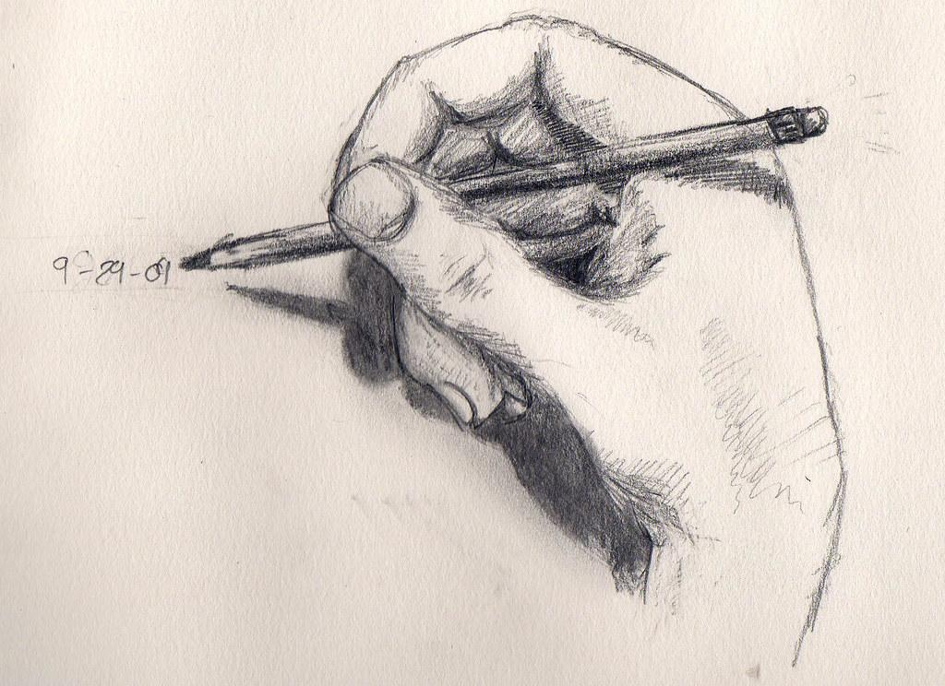
EXTRA CREDIT!
You may earn 5 extra credit points (or enough points to earn a 50/50) if you include your own illustrations related to your story!


Disclaimer: Anything that you write and submit for a grade should be school appropriate. If you have to ask yourself, “Is this school appropriate?” it probably isn’t.

Sample Short Story:

