Assignment: 5..07 TGA- Procedural Essay 50 points

Overview:
For this assignment you will write a Procedural Essay [aka a “How To” essay] that is 1 ½- 2 pages in length. Clearly state your topic, and fully explain all steps necessary to complete the procedure.

Your Procedural Essay Must Include*:

  - An introduction paragraph
  - A thesis statement
  - Proper formatting with indentations and numbered steps
  - Second Person Point of View
  - Transitions between each step
  - At least three examples of vocabulary relevant to your topic and defined, if needed
  - Language appropriate for your audience
  - Three adjective phrases throughout
  - Three examples of media (pictures) that supports or explains your procedures

How To Use This Guide:

- Each step will walk you through the process of PLANNING your procedural essay–be sure to read through all pages of the document and complete ALL the steps
- There are places to make notes that will help you ORGANIZE your ideas
- You will need to WRITE the actual procedural essay in a SEPARATE DOCUMENT to be submitted in the classroom.
- You will submit your procedural essay in Lesson 5.07 of the OMHS

*Please review the sample procedural essay at the end of this document for clear directions on how to incorporate all of these requirements into your own procedural essay.

STEP 1: Choose Your Topic

- Make sure your topic is clear.
- Avoid vague ideas, such as "Cooking Dinner”--instead, make it more specific, such as "How to Roast a Chicken."

Add Your  Topic Here→ | How to

STEP 2: Write Your Thesis Statement

Create a thesis statement that introduces and clarifies your topic.
Example 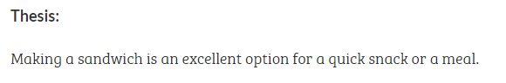
Add Your
Thesis Statement Here→

Step 3: List the MATERIALS NEEDED to complete your task

Think through ALL the materials your task requires.
Example for the topic “How to Make A Sandwich”:
- 2 slices of bread
- A plate
- A butter knife
- Some mayonnaise
- 2 pieces of deli ham
- Toppings

List the Materials Needed for YOUR task here →

Step 4: List the Steps You Must Take to Complete Your Task

Make a LIST of the steps it takes to complete your task. Then,have someone else try them out. Make sure it’s someone honest, who will tell you whether or not your steps are thorough. Clarify your steps where they were confusing or too vague to follow.
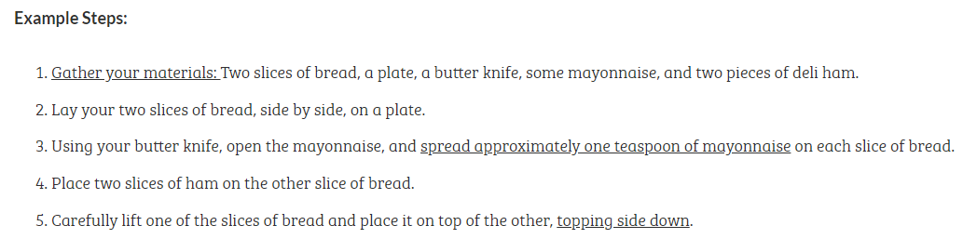

List the Steps to Complete YOUR Task here → | 1-  2-  3-  4-  5-

Step 5: List and Define Vocabulary Specific to Your Procedure

Your task will most likely have specific vocabulary terms.
- Make a list of these words
- Define these words [See Lesson 5.05 for more info about this step.]

Example for the topic “How to Make a Sandwich”:
Term–Toppings
Definition-the items you add between the break of a sandwich, such as meat, cheese, lettuce, tomatoes

Term–Condiments
Definition-something used to give a special flavor to food, as mustard, ketchup, salt, or spices

 | Term | Definition
List and define Vocabulary terms related to YOUR task here→

Step 6: Find MEDIA/PICTURES to go along with your task
There are many types of media that you can use to enhance your procedural essay:
- Diagrams
- Graphics
- Pictures
- illustrations
Each of these types of media brings detail and depth to your essay. They assist the reader in creating a mental image of the procedure being described and help the reader follow the procedure.

Find THREE relevant pictures, diagrams, graphics or illustrations that you can add to your procedural essay. Copy/paste them below:
#1 | #2 | #3

Step 7: Draft Your Procedural Essay

Now it’s time to WRITE your essay!
- Open a NEW document to type your essay.
- Use the notes you have made in the steps above.
- Be sure to include the following elements:
  - An introduction paragraph
  - A thesis statement
  - Proper formatting with indentations and numbered steps
  - Second Person Point of View
  - Transitions between each step
  - At least three examples of vocabulary relevant to your topic and defined, if needed
  - Language appropriate for your audience
  - Three adjective phrases throughout
  - Three examples of media (pictures) that supports or explains your procedures

Use the EXAMPLE ESSAY and RUBRIC below to guide you.

EXAMPLE Procedural Essay

How to Plant a Vegetable Garden
Intro paragraph  Thesis statement is highlighted | Do you know where the vegetables you eat come from? Probably, you do not. They might be grown locally if you buy them at a local farmers’ market, or they might come from another country if you purchase them at the grocery store. One way to always know exactly where your vegetables come from is to grow them yourself. When you grow your own vegetables, you know how they were grown and when they were harvested. Nothing tastes better than a carrot just pulled from your garden. Planting your own vegetable garden is easy and rewarding.
Body Paragraphs | The first step in planning your own vegetable garden is deciding where to plant it. You will want to choose a site that gets lots of sun, but doesn’t bake in the sun all day. You need to be able to easily irrigate (water) it, so it should be close to a water source. Decide on your location and move on!  Next, you will need to prepare the soil. If the area has been gardened before, you won’t have to do as much. If the garden is brand new, there are some things that must be done. First, remove any sod, weeds, grass, and rocks from the ground. This can be done with a shovel or digging fork. Don’t forget to recycle the organic materials in your compost bin or through a program in your town.  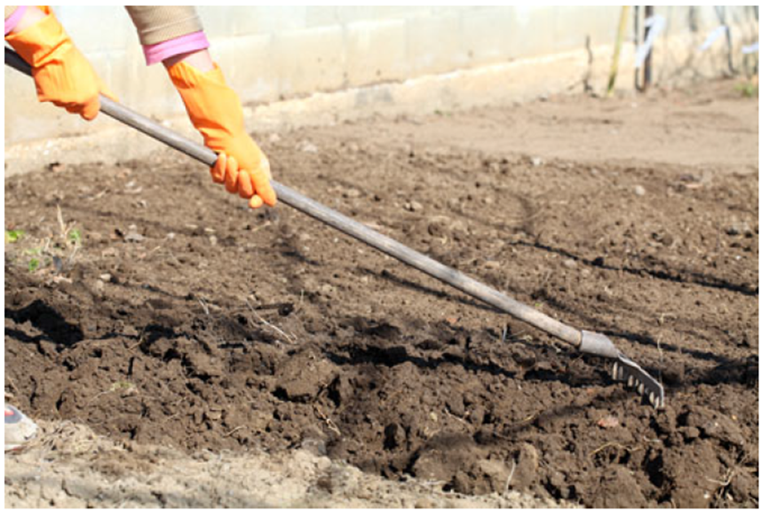  You want to have dark, rich soil in your garden, so if the soil in your area is less than perfect, you should add garden soil and/or some sort of fertilizer. Use your garden fork or shovel to mix the fertilizer and the soil. The soil should be loose and easy to dig in.  When your soil is ready, you are ready to plant! You can plant seedlings (small plants that have been growing in a greenhouse) or seeds. Seeds will need to be planted earlier in the growing season than seedlings will. Following the directions on the seed package or seedlings, plant your vegetables in neat, straight rows. Some plants should be planted farther apart than others, and it will say so on the package. For planting, you will need a garden trowel, which makes digging easier.  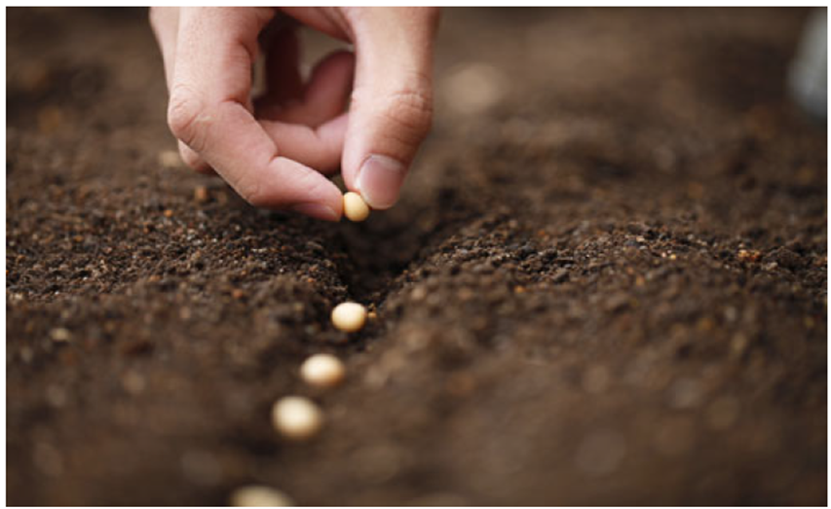  After your vegetables are planted, you will need to water and maintain the garden. Keeping weeds out of the garden will help your plants grow more quickly and healthily. Weed your garden at least once per week by pulling the weeds out with their roots. Use a trowel for stubborn weeds.  You will need to water your garden to keep the soil moist for growing. Depending on the climate where you live, you should water your garden daily or every other day. Water the garden so that the soil is moist to the touch but not pooling with water.  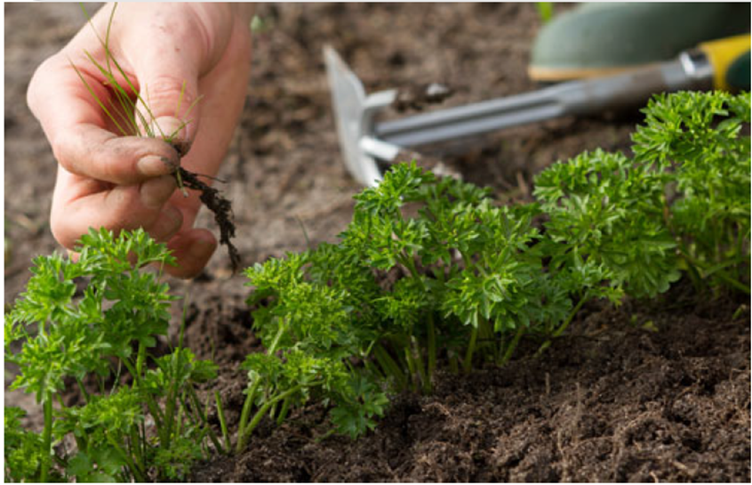  Each vegetable will ripen at a different rate, so read the package that the seeds or seedlings came in to see how many days it will take for the vegetables to mature. When the vegetables are done ripening, harvest them according to the directions on the package.  When the growing season is over, it is important to ready your garden for winter. Do so by weeding and cutting back large plants. Cover your garden with lawn clippings and wait for spring to begin the process again.
Conclusion paragraph | Planting your own garden might take some work, but it is worth it in the end. By knowing where your vegetables come from, you will have the peace of mind that they are pesticide-free and fresh. You will also not add to the price of importing vegetables hundreds or thousands of miles from the farm to the store. The satisfaction you will gain from growing your own garden is also immeasurable.

Rubric: Procedural Essay (50 points)
Criterion | Exemplary (45-50 points) | Proficient (37-44 points) | Emerging (30-36 points) | Not Evident (below 30 points)
Topic  Points Possible: 6 | Student chose a procedural essay topic that is an appropriate length and complexity for the assignment. | Student chose a procedural essay topic that is somewhat lengthy or short for the assignment. | Student chose a procedural essay topic that is too simple or too complex for the assignment. | Student did not choose an appropriate procedural essay topic.
Point of View Uses second person point of view  Points Possible: 5 | Student uses second-person point of view correctly and consistently. | Student uses second-person point of view correctly but not always consistently. | Student uses second-person point of view inconsistently or incorrectly. | Student did not use second-person point of view consistently or correctly.
Essay-  Write a how-to essay  Points Possible: 10 | Student expertly composed a –2 page procedural essay that includes all necessary steps in sequential order. | Student appropriately composed a –2 page procedural essay that includes necessary steps in sequential order. | Student composed a procedural essay that is somewhat less than pages. One or two steps may be missing or out of sequence. | Student composed a procedural essay that is somewhat less than one page. Multiple steps are missing or not in sequence.
Thesis Statement-  Write a thesis statement  Points Possible: 5 | Student wrote a clear, strong thesis statement. | Student wrote a clear thesis statement. | Student wrote a thesis statement. | Student did not write a thesis statement.
Transitions and Vocabulary-  Use transitions appropriate to the pattern of organization  Points Possible: 6 | Student expertly used transitions appropriate for sequential organization. Vocabulary was relevant to the topic and defined when appropriate. Student used an adjective clause correctly. | Student used transitions appropriate for sequential organization. Vocabulary was relevant to the topic but not always defined when appropriate. Student used an adjective clause correctly. | Student generally used transitions appropriate for sequential organization. Vocabulary was somewhat relevant to the topic or not defined when appropriate. Student used an adjective clause. | Student did not use transitions appropriate for sequential organization. Vocabulary was not relevant to the topic or not defined when appropriate. Student did not use an adjective clause.
Conclusion-  Write a concluding paragraph that summarizes main ideas or major points  Points Possible: 5 | Student expertly wrote a concluding paragraph that summarizes main ideas or major points and restates thesis in a new way. | Student appropriately wrote a concluding paragraph that summarizes main ideas or major points and clearly restates thesis. | Student wrote a concluding paragraph that summarizes main ideas or major points with a vague or general restatement of thesis. | Student did not write a concluding paragraph that summarizes main ideas or major points and/or does not refer to thesis.
Media-  Include at least 3 multimedia and visual displays to enhance the presentation  Points Possible: 10 | Student included at least THREE effective and appropriate multimedia and visual displays to enhance the essay. | Student included 2-3 appropriate multimedia and visual displays to enhance the essay. | Student included 1-2 multimedia and visual displays that were loosely related to the essay. | Student did not include multimedia and visual displays, or media did not enhance the essay.
Mechanics/ Conventions  Use complete sentences and correct capitalization, usage, punctuation, and spelling  Points Possible: 3 | Student followed the rules for English grammar and included more than one adjective phrase; 0–3 errors are present. | Student followed the rules for English grammar and included at least one adjective phrase; 4–6 errors are present. | Student followed the rules for English grammar and included one adjective phrase; 7–9 are errors present. | Student did not follow the rules for English grammar nor include one adjective phrase; 10 or more errors are present.

